Project Development Phase
Model Performance Test

Date | 20 February 2026
Team ID | LTVIP2026TMIDS80676
Project Name | FreelanceFinder: Discovering Opportunities, Unlocking Potential
Maximum Marks

Model Performance Testing:
S.No. | Parameter | Values | Screenshot
1 | Model Summary | MERN-stack web application including React frontend, Node.js/Express backend, and MongoDB database for project management, proposal handling, and submission tracking. | FIG 1
2 | Accuracy | Training Accuracy – Not Applicable (No ML model used) Validation Accuracy – System functionality validated through API testing and UI testing. | FIG 2
3 | Fine Tuning Result (if Done) | Validation Accuracy – Not Applicable (No machine learning model implemented; performance measured via functional testing and response time). | FIG 3

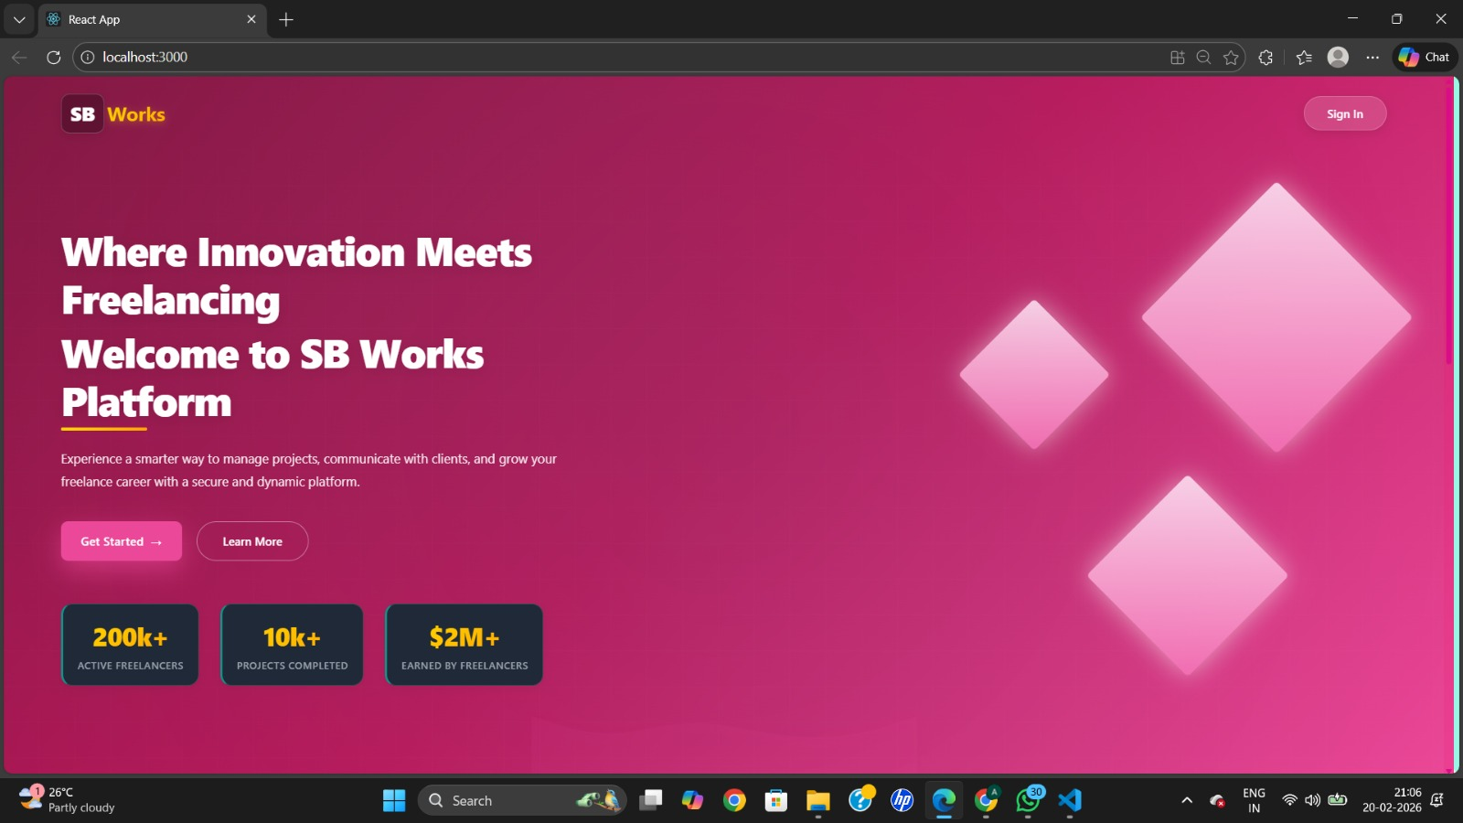

FIG 1:User Interface
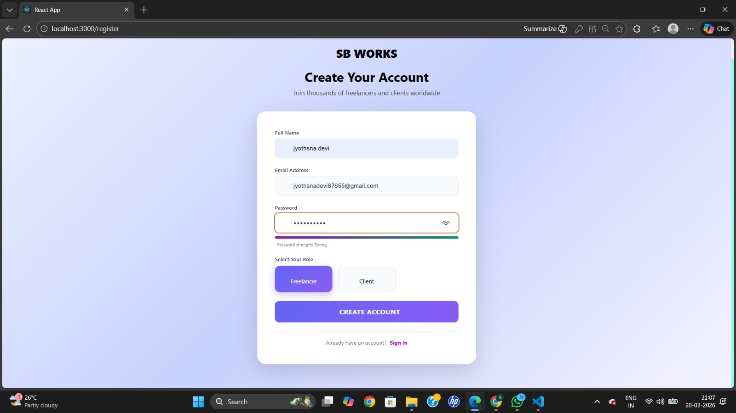
FIG 3: Freelancer Dashboard
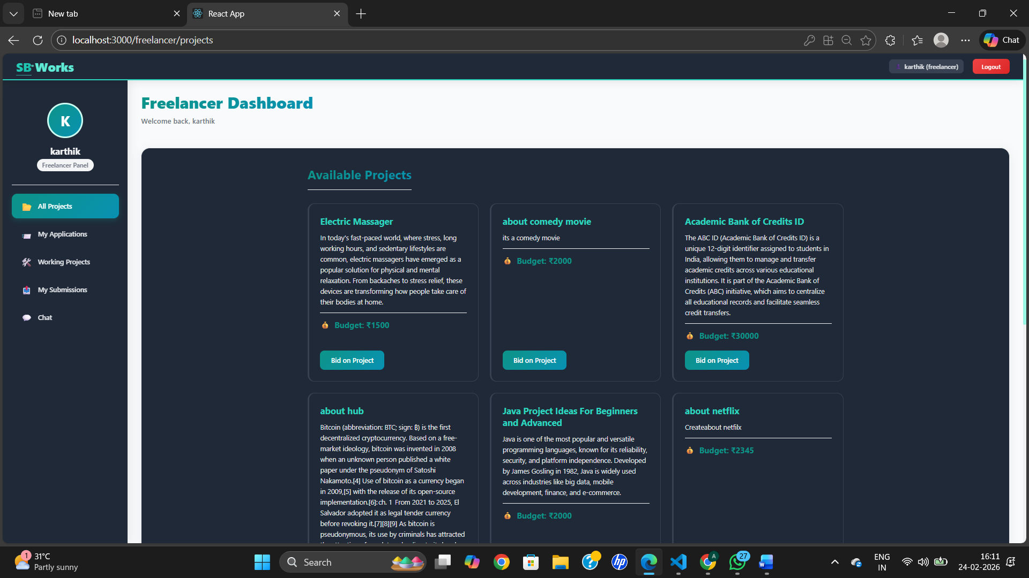
FIG 2:Login Page

